Jack Spicer and Joshua Pollock

Lab 04: Grade Calculator

Lab Section 1

October 3, 2016

**Problem Statement:**

The problem given to us was to create multiple functions that would calculate and return grades based on lists and floating point numbers as grade weights. The problem had a few requirements that we had to follow. These requirements included:

* Several different functions that calculate different things
* A main function that calls upon the other created functions in order to solve the problem
* Floating point numbers to act as the grade weight based off of 3 categories
* Tests = 0.6
* Quizzes = 0.2
* Homework = 0.2
* The use of 6 total lists that are the receive score and the possible scores of the three categories
* Homework = [39, 40, 29, 40, 0, 5]
* Homework Max = [40, 40, 40, 40, 40, 5]
* Quizzes = [10, 10, 9, 2, 10, 10, 10]
* Quizzes Max = [10, 10, 10, 10, 10, 10, 10]
* Tests = [293, 284, 300]
* Tests Max = [300, 300, 300]
* Print commands in order to display the grades of each category and the total final weighted grade

**Planning:**

Planning for the code was very quick. We decided that we would follow along the Lab 04 pdf file and jump right into coding for the program. Beforehand, we did take a picture of the example code on the board to help us understand what exactly we were supposed to do. We decided on using functions, lists, variables, basic algebraic functions, return functions, round functions, and print statements in order to fulfill the requirements of the lab. Using these we would be able to create a code that solved the problem of the lab.

**Implementation and Testing:**

Implementing our planned solution into code was very simple. The Lab 04 pdf file helped to provide a skeleton for our code. We did get confused on how functions work, but upon asking an instructor for assistance, our confusion was cleared up. The instructors also reminded us that the def main(): should be the last function in our code. Another hiccup that occurred was with the round function. For some reason, when we rounded the variable final_grade, the round function set it to 100 instead of 90 or 91. This is why our codes final grade is unrounded. These few issues are the only hiccups that we ran in to, and programming the rest of the code went smoothly. Making the code pep8 compliant was also simple. It was the general, ‘line is too long’, errors. These were easy to fix as we just had to split up some of the calculations and other lines of code. 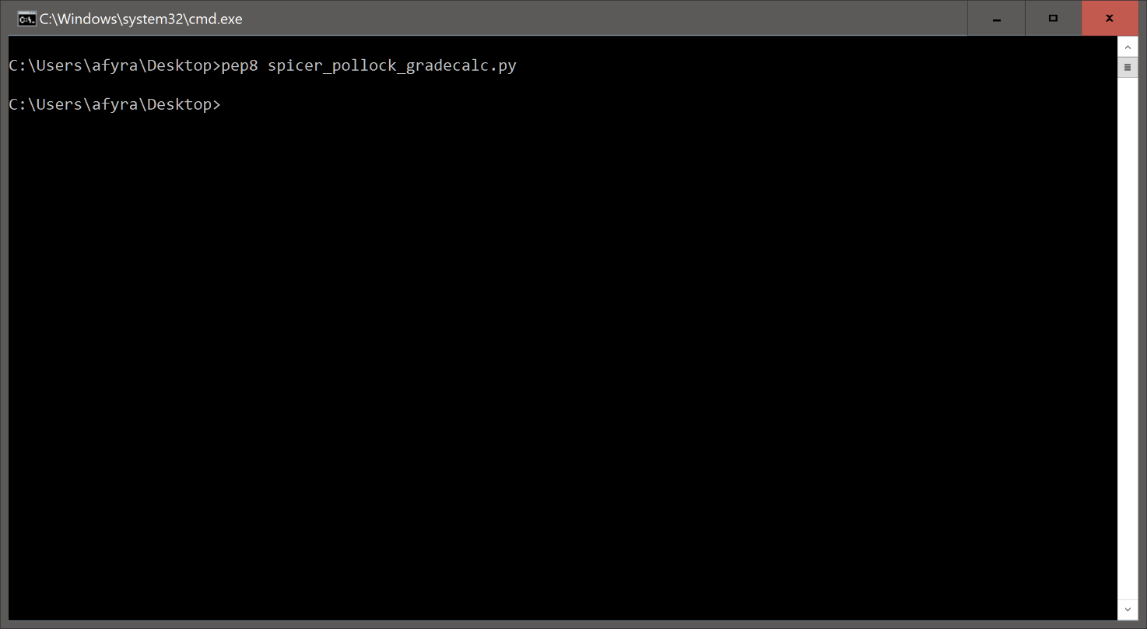

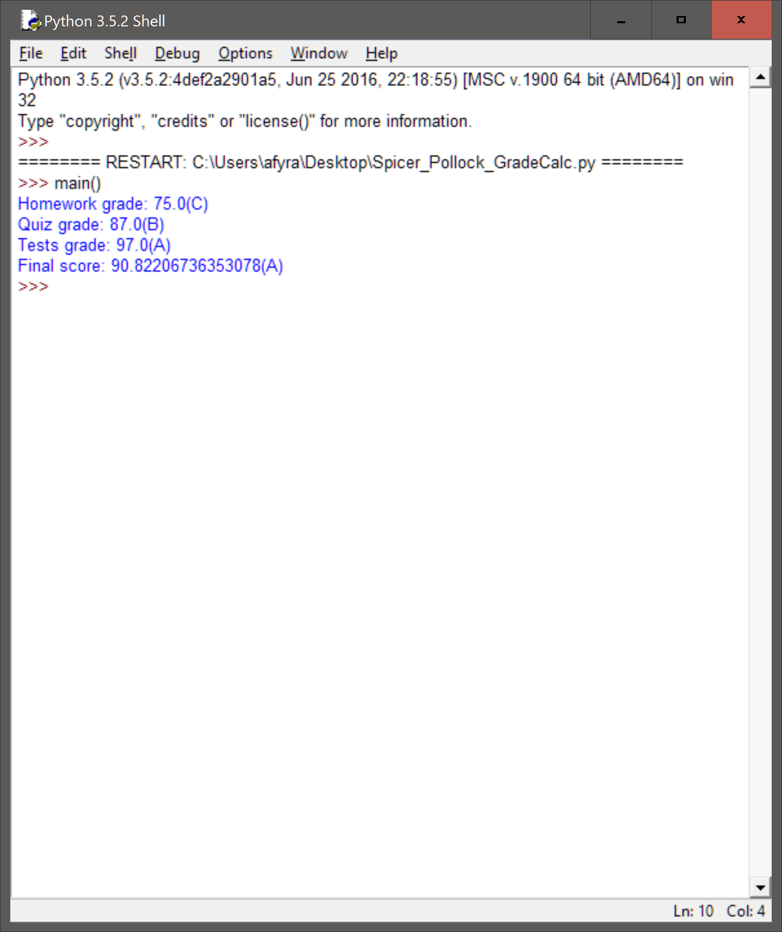

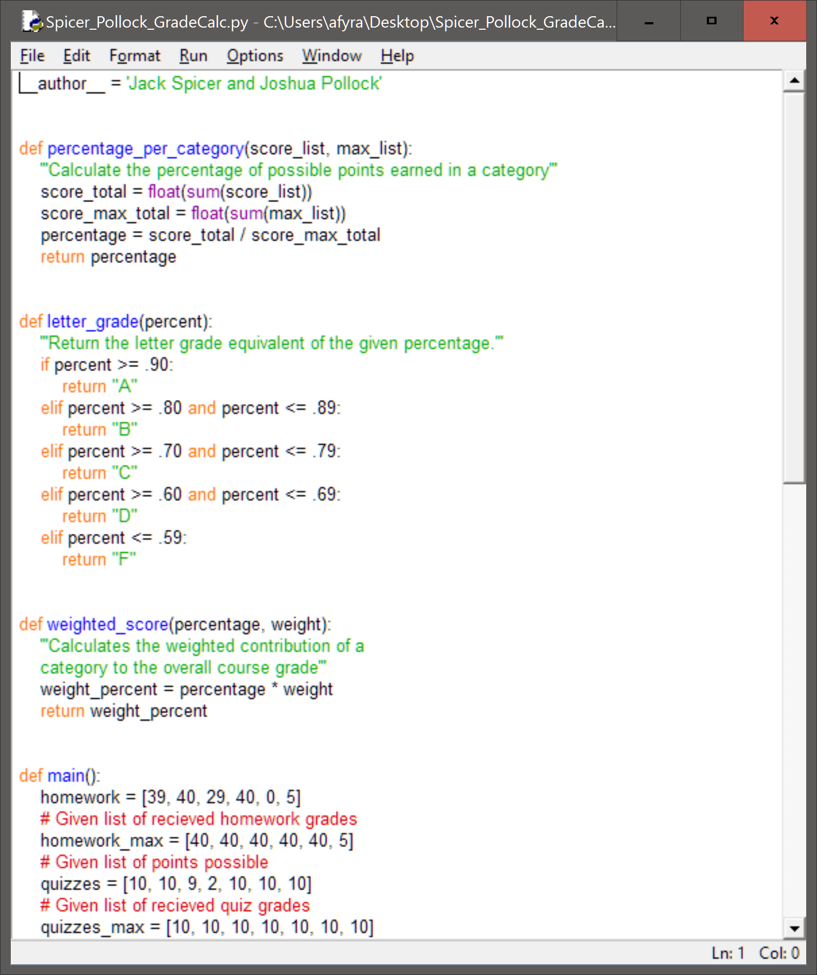

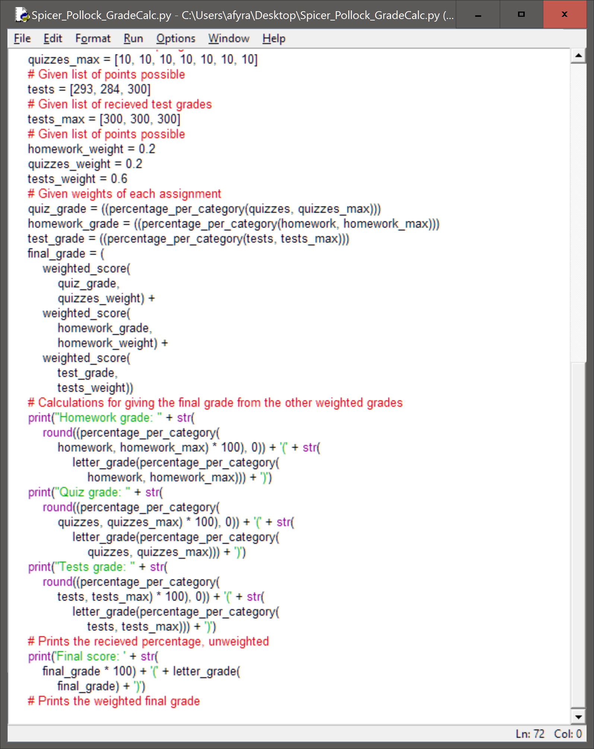

**Reflection:**

Overall we completed this assignment to the best of our abilities. We were quite happy with how the functions started to come out as we started to write the program. I think we could have cleaned up our main function however. The statements that print the test, quiz, homework, and final grade are very long. It would be more precise if we could have broken up chucks of that into different variable names within main. That we do not have such long statements. We could have created a formula or another function and put those statements inside of it. Overall we created source code that was very precise streamline and to the point. We are very happy with the finished product.